Global Issues: Crime and Security – Politics

Setting the Scene – Global Trends in Security
Is the world getting less secure?
It certainly seems like it. Despite optimistic studies in the early 21st century that we were entering – relatively speaking – the most peaceful, least violent period in human history, recent years have seen an increase in the number of armed conflicts and rising lethality (i.e. a greater number of deaths in armed conflict). See Figures 1 and 2.
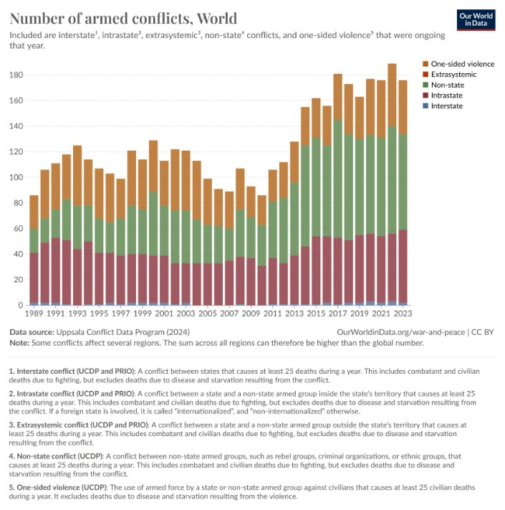
Figure 1 https://ourworldindata.org/war-and-peace?insight=armed-conflict-is-common-and-takes-different-forms#key-insights
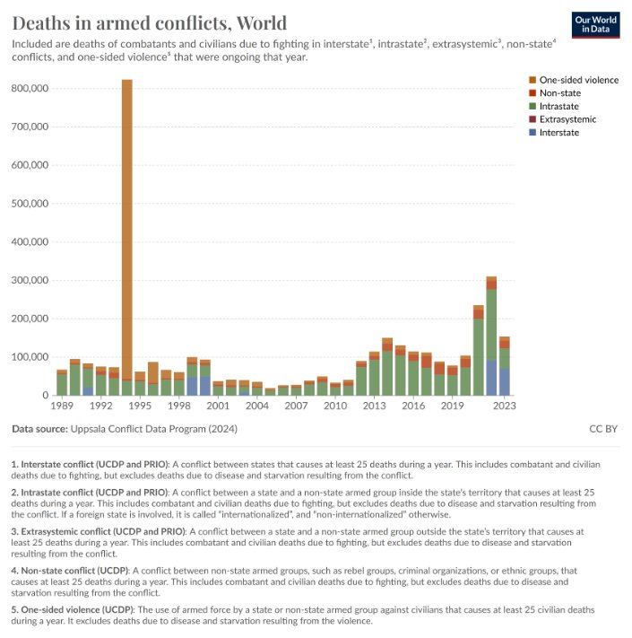
Figure 2 https://ourworldindata.org/war-and-peace-data-explorers
That said, it’s important to keep these numbers in perspective when we look at global patterns of causes of death – the chances of dying in armed conflict or as a result of terrorism or homicide are (relatively) tiny. See Figure 3.
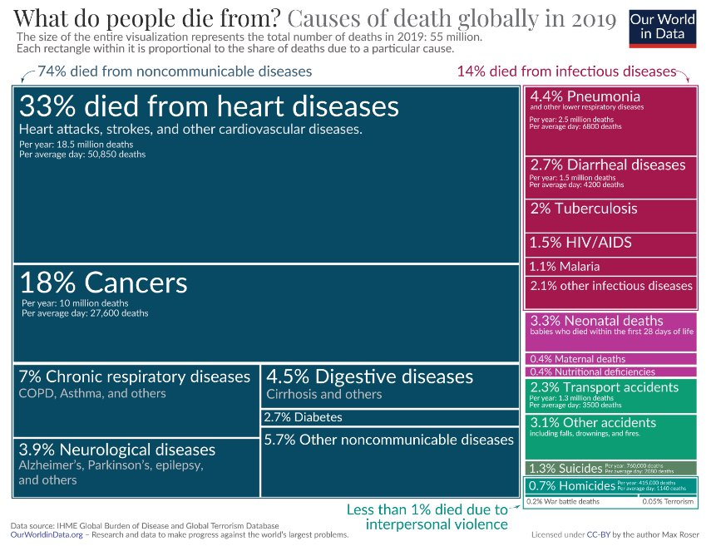
Figure 3 https://ourworldindata.org/causes-of-death
And in spite of the apparent frequency of armed conflicts, we should also look at other important trends to understand global security – for example, the increased proportion of countries that have formed so-called ‘security communities’ where war between members has become unthinkable and the relative decline of severe interstate rivalries where violence is frequent. See figure 4.
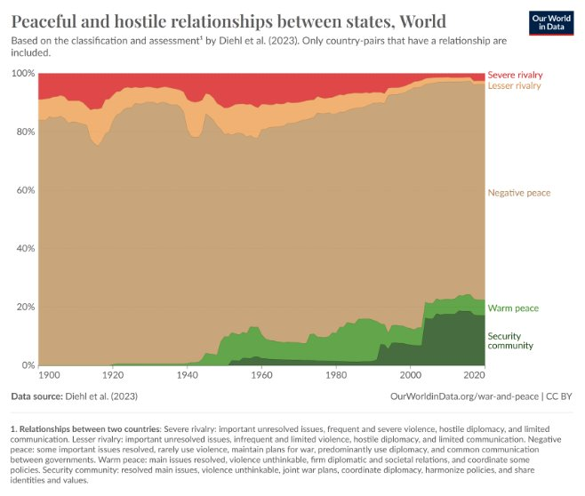
Figure 4 https://ourworldindata.org/war-and-peace?insight=relationships-between-countries-have-become-more-peaceful#key-insights
But war and armed conflict aren’t the only things we need to consider when thinking about global patterns and trends in security – the threat of climate change, for example, or the prevalence of male violence against women and girls, are also clearly relevant to these discussions.
This raises important questions for the study of security – security for whom, security from what, what counts as a security issue (and who gets to decide), and how security can be achieved. We’ll return to some of these questions later, focusing on international security in particular.

A Political Perspective on crime and security
What does a political perspective on crime and security entail? It could mean lots of things (remember some of the themes of my first lecture – agency, choice, collective action, conflict and cooperation, values, interests and so on) but one of the core ideas I want to emphasise to frame our discussion of security and crime is the central importance of the state.
This importance will be developed – and criticised – as we move through the themes of the lecture, but a good starting point is the seeming paradox neatly expressed by Hugh White:
‘…states are both essential for the security of individuals, and also at the same time are among the biggest threats to them.’
This captures a lot of the complexities of the issues we’re looking at: the source of threats, possible protectors from those threats, and who security is for, i.e. who is to be protected (individuals, in this formulation, but this can also be debated – as we’ll see later, there are disagreements over whether is it the state itself that needs to be secured, or individuals, or something else entirely).
The idea that the state can be both a source of and a protector from insecurity has a long tradition and a historically informed perspective tells us that the state has had both pacifying effects domestically and has been capable of organised violence on a horrifying scale.
The scholar Charles Tilly famously compared the state to a protection racket:
“If protection rackets represent organized crime at its smoothest, then war making and state making – quintessential protection rackets with the advantage of legitimacy – qualify as our largest examples of organized crime. Without branding all generals and statesmen as murderers or thieves, I want to urge the value of that analogy. At least for the European experience of the past few centuries, a portrait of war makers and state makers as coercive and self-seeking entrepreneurs bears a far greater resemblance to the facts than do its chief alternatives: the idea of a social contract, the idea of an open market in which operators of armies and states offer services to willing consumers, the idea of a society whose shared norms and expectations call forth a certain kind of government.”
From the comfort of the relative safety and security of a modern western European state where it’s almost a cliché to affirm that the first role of government is to protect its citizens, a wider understanding (historically and geographically) of the politics of crime and security has to also consider the extent to which states can be both security-providers and sources of insecurity and perpetrators of crimes as well as enforcers of law and order.

Political Crimes and Criminal Politics
So, a political perspective on crime and security has to acknowledge the many complex ways in which political authority (formal and informal), criminal activity (by state and non-state actors) and security provision (by public and private actors) can overlap without clear-cut distinctions. We can’t cover all the dimensions of this in one lecture, but here are a few broad ideas and themes for you to think about.
State crimes and state violence
- States are among the worst perpetrators of crimes, from corruption and bribery to human rights abuses, wars of aggression and crimes against humanity​
- States also use and exploit organised crime as instruments of statecraft to serve their foreign policy objectives​
  - For current examples see Galeotti on Russia, Mailey on Iran
- In some cases, the state and organised crime are so closely linked that they have been labelled as 'Mafia States' (e.g. Russia)
Criminal politics
- Barnes has argued that some criminal organisations, in some contexts, behave in ways that can in fact be very similar to how we traditionally think of the role of the state, and in particular through the “the accumulation of the means of violence”, thereby attaining a high level of political authority.
- He also notes how criminal organisations can develop both competitive and collaborative relationships with the state, further complicating how we understand the links between politics, the state, and crime.
Criminal governance
- In a similar vein of research, Lessing has shown how there are parts of the world, especially but only in urban areas in the developing world, where it is criminal actors who govern the population not the state, undermining what is usually considered the defining feature of the state – a legitimate monopoly on the use of force within a territory.
- As with Barnes’ argument, Lessing also emphasises that there is no binary division between state governance and criminal governance in these areas; rather, they exist alongside each other, albeit in a fractious way: “residents may pay taxes, vote, and even inform on gangs as punishment for abusive behavior. Criminal governance flourishes in pockets of low state presence, but ones that states can generally enter at will, if not always without violence.”
The crime-conflict nexus
- Research also tells us that that crime and (political) conflict are often found alongside each other, not least in the ways that non-state armed actors – rebels, terrorist organisations – fund their activities.
- Greed vs grievance: There is a long running debate in civil war research on the primary causes of and motives behind rebellion, with some seeing it as essentially a form of enrichment (greed) while others focus more on the political demands rebels make when, for example, they are excluded from power (grievance).
And now all this happens in the context of a highly globalised economy, with all this entails for the potential of transnational organised crime to fuel conflict and vice versa (note for example Afghanistan and Myanmar on this map from 2010, and the flow of weapons from Ukraine to East and Central Africa):
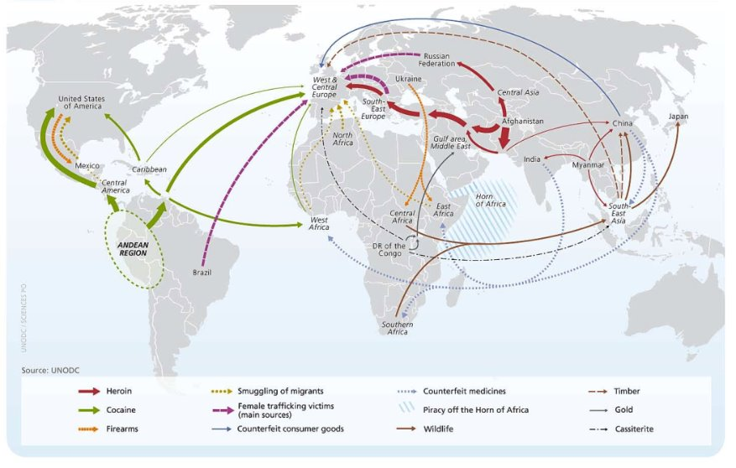
Figure 5 ‘The Globalization of Crime - A Transnational Organized Crime Threat Assessment’. United Nations Office on Drugs and Crime, 2010. //www.unodc.org/unodc/en/data-and-analysis/tocta-2010.html.

What is (international) security?
Having set out some of the broad contours of what a political perspective on crime and security involves, we will now focus on some of the key ideas and debates in international security – and while this may seem to suggest a concern with security between states, as we’ve already seen in could be problematic to draw a clear line between what happens between states and what happens within states when it comes to the politics of crime and security.
Some of the key questions that have preoccupied scholars of security include:
- What is security?​
- Whose security are we talking about?​
- What counts as a security issue? ​
- How can security be achieved?
Security is an ‘essentially contested’ concept ... and unavoidably political. It has been said that security is an unending political argument about what matters. ​
A common working definition used by International Relations scholars is that security is “the alleviation of threats to cherished values”. Some add that this also has subjective aspects – that is, an absence of fear of threats as well as the alleviation of an objective threat. But this definition immediately raises more questions than it answers: What threats? What values? Whose values?​ The political nature of security becomes clear when we start to think about the trade-offs between security and other things we care about such as balancing security and freedom, a fear of external aggressors versus fear of the state, a desire for the government to spend public money on things like health and education versus investment in defence … and so on.
A key debate in security studies has been over whether security should be narrowly or broadly defined. Essentially, these are debates over the 'referent object' of security – who or what is being secured.
Traditionally (within IR), a narrow perspective on security has identified the state (or perhaps the nation) as the appropriate referent object for security and focuses mostly on military threats (perhaps unsurprisingly as the academic study of security emerged during the Cold War). More recently, many have argued for adopting a far wider definition of security on a spectrum from the security of individuals to the security of the planet (we’ll look at some of these in more detail later).
Think/reflect:
- Which of these examples from the lecture did you think are (or should be) security issues? Why?
- What are the relevant referent objects, sources of threat, and possible security providers?
- What are the implications for political choices and security policy of adopting a definition of security that is very narrow or very wide?

Perspectives on (International) Security
Security studies, as a subfield of International Relations, is vast – so my aim here is to give you a brief introduction to some of the main, influential perspectives on international security. The handbooks listed in the resource list on Canvas will give you plenty of material to pursue your interests further.
We’ll start with the security dilemma – not a perspective itself but an important idea at the heart of a lot of debates about international security – and then consider the three predominant theoretical traditions in IR theory – realism, liberalism and constructivism. Each has multiple variations – hence realisms etc in the plural – so these are just a very few of the core ideas that characterise the approaches to give you a sense of how IR scholars have thought about international security.
Then we’ll look at some more recent developments – prompted in part by the end of the Cold War (but with longer histories) – in security studies and perspectives that have attempted, in different ways, to build on or challenge and move beyond the more traditional approaches.

The Security Dilemma
The security dilemma is a key idea in international relations that is frequently used to explain major threats to world peace and security including arms races and war (it has been applied to both interstate and civil war), including preventive war.
The basic logic is as follows:
- Actions taken by a state to increase their security (such as building up their military, forming alliances, developing missile defences) …
- … make other states feel less secure and therefore reciprocate, taking similar measures to increase their security …
- … which increases tension and a mutual sense of fear and insecurity …
- … which can lead to conflict, potentially even war.
- Crucially, this dynamic is possible even if both sides had purely defensive intentions (at least initially)
- The problem is that defensive measures (in the ‘self-help world’ of international relations where there is no higher authority providing security) are potentially offensive as well (almost all military systems can be used both defensively and offensively)
- So, everyone ends up less secure; hence, the ‘tragedy’ of international politics
Note that there are of course many other possible pathways to war such as aggressive intentions, greed, empire building etc.

Realisms
- Primacy of the state as security-seeking (or security-maximising) actor concerned above all with survival (of the state) in conditions of international anarchy (a 'self-help world') ​
- Explanations focus on factors working from the ‘outside-in’ – the international system shapes and shoves how states can and should behave
- Focuses on material factors (balance of military power, geography, economic strength)​
- Very pessimistic outlook ​

Liberalisms
- Greater emphasis on individuals (analytically and normatively) and the role of international institutions in facilitating cooperation ​
- Explanations focus more on factors working from the ‘inside-out’ – that is, the importance of domestic variables (e.g., democratic peace)​
- More optimistic outlook

Constructivisms
- Ideas (and not just material factors) matter, which opens up space for change (e.g. a shift from state security to human security – more on this later) ​
- Core concepts in international security – anarchy, national interests, the balance of power etc. – are not fixed, objective facts 'out there' but are socially constructed ​
  - E.g. relations of enmity and amity are not 'given' but are social constructions: “Five hundred British nuclear weapons are less threatening to the US than five North Korean ones because of the shared understandings that underpin them.”
- Crucial for understanding the importance of norms and identity in international security.

Securitisation
Securitisation is associated with the so-called Copenhagen School and was developed initially by Buzan and colleagues, but has subsequently been refined and developed in many directions.
The core ideas, as articulated by Buzan et al, is as follows:
- "the meaning of a concept lies in its usage."​
- "Security is […] a self-referential practice […] it is in this practice that the issue becomes a security issue – not necessarily because a real existential threat exists but because the issue is presented as such a threat." ​
  - 'Saying security is doing security'​
- "when a securitizing actor uses a rhetoric of existential threat and thereby takes an issue out of […] 'normal politics', we have a case of securitization"​
- This legitimises the use of extraordinary measures – security is defined by exception and emergency (rather than e.g. democratic procedures in 'normal' politics)​
- "it is always a political choice to securitize or to accept securitization." ​

e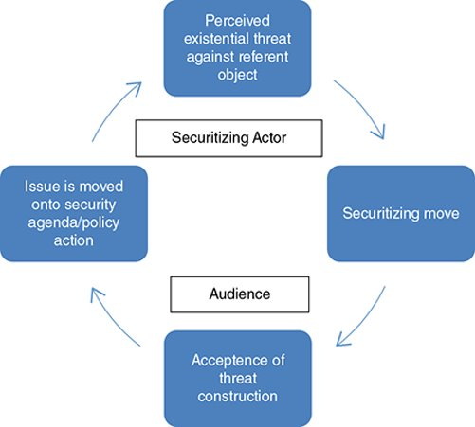
Figure 6 Courtesy of Mark Webber
If securitisation is the process by which issues become part of the security agenda, desecuritisation is the reverse of this process. Scholars concerned with the negative consequences of securitisation (think about migration, for example, and the dangers associated with treating particular issues as requiring exceptional measures in response to existential threats). In desecuritisation, issues that were securitised are moved back into the domain of normal politics
Think/Reflect:
- Think back to our discussion of the politics of climate change, especially the possible links between climate change and armed conflict. Do you think climate change and environmental issues have been (or should be) securitised? What would the implications be? Do you think this would improve political and policy responses to environmental challenges or make them worse?
- Should the alleged link between water scarcity and conflict be desecuritised? Do you think this would make international cooperation easier?

Human Security
An important development in both academia and in international policy circles that started in the 1990s (prompted in part by the end of the Cold War) was a shift in thinking away from prioritising the state as the main referent object of security and towards individual people – hence human security. The basic insight can be summed as: People are ends, states are means to ends.
For academics such as Ken Booth, this shift in emphasis was central to efforts to rethink security: “It is on the position of the state where the conception of security as a process of emancipation parts company with the neo-realist conception … The litmus test concerns the primary referent object: is it states, or is it people? Whose security comes first? I want to argue … that individual humans are the ultimate referent.”
Around the same time, a landmark report by the UN Development Programme – the Human Development Report - introduced the term human security to policy discourse. Note the explicit emphasis on shifting the referent object of security and expanding the definition of the associated security agenda:
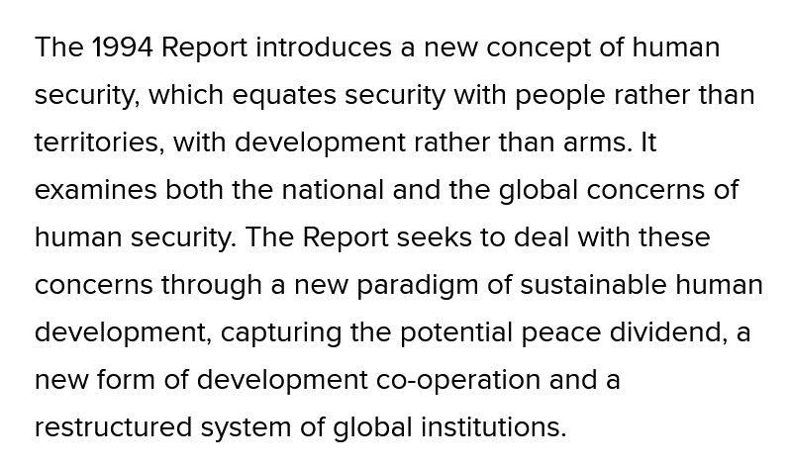

Critical Perspectives
I’m referring here to a very diverse – perhaps incompatible – set of perspectives, but as a broad umbrella term, ‘critical perspectives’ in security studies share some common starting points and arguments.
- Rethinking ‘traditional’ security studies (especially realism)​
- Profound political differences over what security can and should mean​
- Challenging state-centrism and an (over)emphasis on military force of traditional security studies ​
- Addressing the exclusion of marginalised voices (especially feminist and postcolonial perspectives on security – more on these next)​
- Responding to the ‘disciplining’ practices in academia
Scholars such as Ken Booth, quoted above, were closely associated with these developments. And while in some ways the emergence of human security as a widely used concept in both academia and policy suggests a convergence between critical security approaches and policymakers – i.e. making individuals, not the state, the referent object – critical scholars have become sceptical about how human security is used in practice: “Human security … was tamed by states when it became a mere instrument of foreign and development policy within the United Nations (UN) or some key states, distant from the everyday and local security concerns of people and communities”
There are relevant links with securitisation and the Copenhagen School:
- The Copenhagen School fears that issues labelled as ‘security’ will be captured by state elites and addressed through the application of zero-sum military and/or police practices, which may not necessarily help address human insecurities and so argues for desecuritisation (taking issues outside of the security agenda and addressing them through ‘normal’ political processes)
- Critical scholars prefer to hold on to ‘security’ as a concept for scholarly studies while scrutinizing its use in practice.
- Ultimately, whether ‘desecuritisation’ or ‘politicising security’ helps deal with problems is an empirical question – climate change, HIV/AIDs as a security issue may have positive effects; migration as a security threat has been dangerous and dehumanising.

Postcolonial Approaches
Scholars working the postcolonial tradition have strongly criticised traditional approaches to international security which they see as not only Eurocentric but potentially complicit in sustaining hierarchies in the contemporary international system. A useful statement of the postcolonial perspective on international security by Barkawi and Laffey makes some of the following key points:
- ‘Conventional’ security studies “is a poor basis for understanding and action in contemporary security environments.” (e.g. transnational terrorism, al-Qaeda)​
- Why? Eurocentrism (i.e., the categories and assumptions about world politics found in security studies come from an understanding of European experience). ​
- This means that the role of the global South has been systematically understated and misrepresented in security relations. ​
- Eurocentrism also distorts analysis of Europe and its place in world politics. To understand security relations we need to acknowledge “the mutual constitution of Europe and the non-European world and their joint role in making history.” ​
- We can only understand security relations if we “discard Eurocentric assumptions about the world and how it works.”

Feminist Approaches
Gender and security can be studied from a non-feminist perspective (we’ll see some examples of this later), but feminists studying global politics – and global security – “share a normative and empirical concern that the international system is gender-hierarchical”. Some of the common tenets of work in feminist Security Studies include:​
- Broad understanding of security (what counts as a security issue; to whom the concept of security should be applied)​
- Security studies can’t be ‘gender-neutral’. ​
- Gender matters in the theory and practice of international security in many ways: e.g. “it is necessary, conceptually, for understanding international security, it is important in analyzing causes and predicting outcomes, and it is essential to thinking about solutions and promoting positive change in the security realm”​
- Feminist scholars of security: “question the supposed nonexistence of and irrelevance of women in international security politics,” interrogate “the extent to which women are secured by state ‘protection’ in times of war and peace,” contest “discourses where women are linked unreflectively with peace,” and critique “the assumption that gendered security practices address only women.”

Security Institutions – Responding to Insecurity
We discussed the collective action problem in the week on environmental politics in relation to climate change action (or lack thereof). The problems are seemingly even more insurmountable in the security domain which remains firmly within the purview and prerogative of states rather than international organisations. ​
Can international institutions reduce insecurity (between and within states) by promoting cooperation? ​Different theoretical perspectives tend towards pessimism or optimism, based on different starting assumptions​ (think back to what was said earlier about realism and liberalism)
The problem for researchers and analysts is, how do we know if institutions independently promote cooperation, rather than just reflecting the balance of power?
The argument for:​
- Institutions alter behaviour and make defection less likely. ​
- How? Repeated interactions, issue linkage, information sharing, reduced transaction costs, shaping ideas, creating a wider 'we' feeling in security communities ...​
- E.g. the role of the EU and NATO in post-WW2 Europe ​
The argument against:​
- Institutions are tools of statecraft, used by powerful states to serve their own interests​
- Helpful in some circumstances but only when suitable conditions already exist. That is, institutions are effects rather than causes – think about origins of EU: did such peaceful relations between European states emerge because of the institution of the EU, or was the emergence of the institution only possible because of the ‘hard security’ guarantees from the US and the devastation following World War 2?
The United Nations – including the Security Council, which has responsibility for international peace and security – is an interesting and important case to look at as the world’s preeminent international organisation and one of the few with universal membership.
To take one example that connects a few of the themes discussed already, the landmark report ‘A More Secure World’ (2004) illustrates the role of the UN as a norm entrepreneur and legitimising actor that provides specialist knowledge and expertise. These lines from the report clear encapsulate the trend at the time towards a broader definition of security “beyond states waging aggressive wars”:
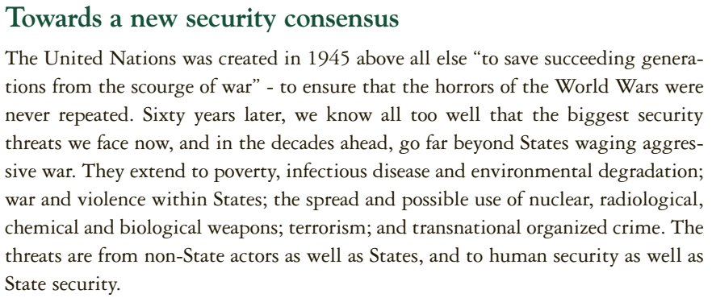
Peacekeeping is perhaps one of the activities most closely associated with the United Nations, for good and bad reasons (and perhaps less so than in the past – operations have been in decline over the last few years).
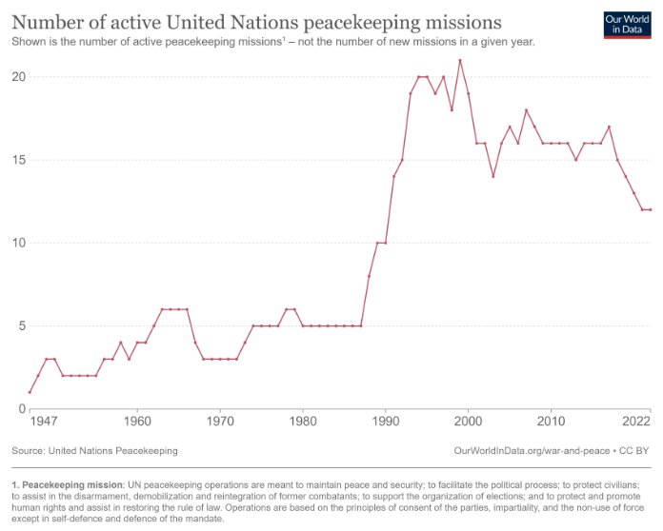
Figure 7 https://ourworldindata.org/war-and-peace

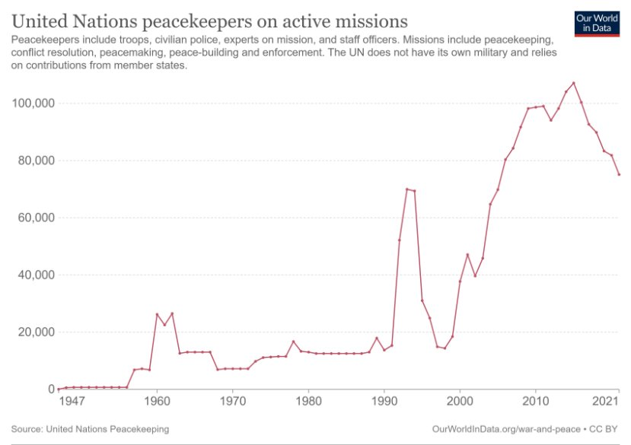
Figure 8 https://ourworldindata.org/war-and-peace

Does peacekeeping work? Yes … sort of, having learned from its many failures especially in the 1990s in places like Rwanda and Bosnia. When peacekeepers are deployed, wars are less likely to recur and violence against civilians declines (compared to case where there are no peacekeepers)​.
Nonetheless, many remain critical. There have also been many major errors (such as when a UN mission accidentally introduced cholera into Haiti) and grievous crimes committed by peacekeepers, notably sexual abuse and exploitation of those the peacekeepers were supposed to be protecting in another example of the disturbing frequency with which those tasked with providing security end up violating it.

Women, Peace and Security
When the UN Security Council passed Resolution 1325 in 2000, it was a 'landmark' development emphasising "the important role of women in the prevention and resolution of conflicts, peace negotiations, peacebuilding, peacekeeping, humanitarian response and in post-conflict reconstruction and stresses the importance of their equal participation and full involvement in all efforts for the maintenance and promotion of peace and security."​
We can see this development as part of the broader trend already discussed in this lecture – a shift in understandings of security from a state-centric approach to a person-centric approach and part of changing norms and ideas about what security is, who it for, and how to go about achieving it.
Resolution 1325 is one part of a much broader WPS cross-cutting agenda and has "significant potential to prevent conflicts, protect human rights, and promote recovery from conflict" (see below for some of the empirical research supporting this agenda’s aims). But progress has been "inadequate" and faced institutional resistance.
A major review conducted 15 years after Resolution 1325 found there had been mixed progress. While there were positive trends in some key indictors – such as an increase in the number of peace agreements that include references to women, a greater number of senior women leaders in the UN, and increases in aid on gender equality – in other areas there had been little progress: level of women participating as negotiators in peace processes and as part of peace operations is very low, funding for WPS programmes and processes is “abysmally low” and doesn’t match the rhetoric, and despite a strengthened legal framework, prosecutions of perpetrators of sexual violence remains low.
The most recent annual report on progress in the WPS agenda “presents a sobering assessment of the lack of progress over the past decade” and offers a ‘stark warning’: “Amid record levels of armed conflict and violence, progress made over decades is vanishing before our eyes. Generational gains in women’s rights hang in the balance around the world.”

Does More Equality for Women Mean Less War?
The WPS agenda is based on an emerging and growing research agenda that is trying to answer this and related questions. As with most interesting and important topics, the findings are still unclear and we don’t know exactly what the relationship is between gender, sex and war. But, several findings are receiving a lot of empirical support:​
- “the very best predictor of a state’s peacefulness is not its level of wealth, its level of democracy, or its ethno-religious identity; the best predictor of a state’s peacefulness is how well its women are treated.” (Hudson)
- Women's representation in parliament, their relative education levels, and lower violence against women are all associated with a lower risk of war​
- Peace processes that include women are more durable (but women are usually excluded)
​

References
Allum, Felia, and Stan Gilmour, eds. The Routledge Handbook of Transnational Organized Crime. Second edition. Routledge., 2022.
Autesserre, Severine. ‘The Crisis of Peacekeeping: Why the UN Can’t End Wars’. Foreign Affairs 98, no. 1 (2019): 101–16.
Baldwin, David A. ‘The Concept of Security’. Review of International Studies 23, no. 1 (1 January 1997): 5–26.
Balzacq, Thierry, Sarah Léonard, and Jan Ruzicka. ‘“Securitization” Revisited: Theory and Cases’. International Relations 30, no. 4 (1 December 2016): 494–531. https://doi.org/10.1177/0047117815596590.
Barkawi, Tarak, and Mark Laffey. ‘The Postcolonial Moment in Security Studies’. Review of International Studies 32, no. 02 (April 2006): 329. https://doi.org/10.1017/S0260210506007054.
Barnes, Nicholas. ‘Criminal Politics: An Integrated Approach to the Study of Organized Crime, Politics, and Violence’. Perspectives on Politics 15, no. 4 (December 2017): 967–87. https://doi.org/10.1017/S1537592717002110.
Barnett, Michael N., and Martha Finnemore. ‘The Politics, Power, and Pathologies of International Organizations’. International Organization 53, no. 4 (1 October 1999): 699–732.
Berdal, Mats. ‘Beyond Greed and Grievance – and Not Too Soon …’. Review of International Studies 31, no. 04 (2005): 687–98. https://doi.org/10.1017/S0260210505006698.
Booth, Ken. ‘Security and Emancipation’. Review of International Studies 17, no. 04 (October 1991): 313. https://doi.org/10.1017/S0260210500112033.
Booth, Ken, and Nicholas J Wheeler. The Security Dilemma: Fear, Cooperation, and Trust in World Politics. Palgrave Macmillan, 2008.
Braumoeller, Bear F. Only the Dead: The Persistence of War in the Modern Age. Oxford University Press, 2019.
———. ‘World War II Was 75 Years Ago. But Big Wars Can Still Happen.’ Washington Post, 2 September 2020. https://www.washingtonpost.com/politics/2020/09/02/world-war-ii-was-75-years-ago-big-wars-can-still-happen/.
Buzan, Barry, Ole Waever, and Jaap de Wilde. Security: A New Framework for Analysis. Boulder, Colo: L. Rienner, 1998.
Cederman, Lars-Erik, Andreas Wimmer, and Brian Min. ‘Why Do Ethnic Groups Rebel?: New Data and Analysis’. World Politics 62, no. 1 (2010): 87–119.
Cohen, Dara Kay, and Sabrina M. Karim. ‘Does More Equality for Women Mean Less War? Rethinking Sex and Gender Inequality and Political Violence’. International Organization 76, no. 2 (ed 2022): 414–44. https://doi.org/10.1017/S0020818321000333.
Collier, Paul. ‘Rebellion as a Quasi-Criminal Activity’. Journal of Conflict Resolution 44, no. 6 (2000): 839–53.
Davenport, Christian. ‘State Repression and Political Order’. Annual Review of Political Science 10, no. 1 (2007): 1–23. https://doi.org/10.1146/annurev.polisci.10.101405.143216.
Davies, Sara E., and Jacqui True. ‘Women, Peace, and Security: A Transformative Agenda?’ In The Oxford Handbook of Women, Peace, and Security, edited by Sara E. Davies and Jacqui True, 0. Oxford University Press, 2019. https://doi.org/10.1093/oxfordhb/9780190638276.013.1.
Diehl, Paul F, Gary Goertz, and Yahve Gallegos. ‘Peace Data: Concept, Measurement, Patterns, and Research Agenda’. Conflict Management and Peace Science 38, no. 5 (1 September 2021): 605–24. https://doi.org/10.1177/0738894219870288.
Finnemore, Martha, and Kathryn Sikkink. ‘Taking Stock: The Constructivist Research Program in International Relations and Comparative Politics’. Annual Review of Political Science 4, no. 1 (1 June 2001): 391–416. https://doi.org/10.1146/annurev.polisci.4.1.391.
Floyd, Rita. ‘Extraordinary or Ordinary Emergency Measures: What, and Who, Defines the “Success” of Securitization?’ Cambridge Review of International Affairs 29, no. 2 (2 April 2016): 677–94. https://doi.org/10.1080/09557571.2015.1077651.
Galeotti, Mark. ‘Gangster Geopolitics: The Kremlin’s Use of Criminals as Assets Abroad’. Russian Matters, 17 January 2019. https://www.russiamatters.org/analysis/gangster-geopolitics-kremlins-use-criminals-assets-abroad.
———. ‘Russia’s Use of Organized Crime as an Instrument of Statecraft’. Global Initiative Against Transnational Organized Crime, November 2024. https://globalinitiative.net/analysis/gangsters-at-war-russias-use-of-organized-crime-as-an-instrument-of-statecraft/.
Goertz, Gary, Paul F Diehl, and Alexandru Balas. The Puzzle of Peace: The Evolution of Peace in the International System. Oxford University Press, 2016.
Goldstein, Joshua S. Winning the War on War: The Decline of Armed Conflict Worldwide. New York: Penguin Group, 2011.
Hudson, Valerie M. ‘What Sex Means for World Peace’. Foreign Policy (blog), 15 November 2024. https://foreignpolicy.com/2012/04/24/what-sex-means-for-world-peace/.
Human Security Report Project. Human Security Report 2013: The Decline in Global Violence: Evidence, Explanation, and Contestation. Vancouver: Human Security Press, 2013.
Karim, Sabrina, and Kyle Beardsley. ‘Explaining Sexual Exploitation and Abuse in Peacekeeping Missions: The Role of Female Peacekeepers and Gender Equality in Contributing Countries’. Journal of Peace Research 53, no. 1 (1 January 2016): 100–115. https://doi.org/10.1177/0022343315615506.
Karstedt, Susanne. ‘Organizing Crime: The State as Agent’. In The Oxford Handbook of Organized Crime, edited by Letizia Paoli, 0. Oxford University Press, 2014. https://doi.org/10.1093/oxfordhb/9780199730445.013.031.
Keating, Joshua. ‘It’s Not Your Imagination. There Has Been More War Lately.’ Vox, 25 January 2024. https://www.vox.com/world-politics/2024/1/25/24049551/war-increasing-ukraine-gaza-sudan-ethiopia.
Krause, Jana, Werner Krause, and Piia Bränfors. ‘Women’s Participation in Peace Negotiations and the Durability of Peace’. International Interactions 44, no. 6 (2 November 2018): 985–1016. https://doi.org/10.1080/03050629.2018.1492386.
Krause, Keith. ‘Critical Theory and Security Studies: The Research Programme of `Critical Security Studies’’. Cooperation and Conflict 33, no. 3 (1 September 1998): 298–333. https://doi.org/10.1177/0010836798033003004.
———. ‘Emancipation and Critique in Peace and Conflict Research’. Journal of Global Security Studies 4, no. 2 (1 April 2019): 292–98. https://doi.org/10.1093/jogss/ogy049.
Lessing, Benjamin. ‘Conceptualizing Criminal Governance’. Perspectives on Politics, undefined/ed, 1–20. https://doi.org/10.1017/S1537592720001243.
Mailey, J. R. ‘Iran’s Criminal Statecraft: How Tehran Weaponizes Illicit Markets’. Global Initiative Against Transnational Organized Crime, October 2024. https://globalinitiative.net/analysis/irans-criminal-statecraft-how-teheran-weaponizes-illicit-markets/.
Orlova, Alexandra V. ‘Russia: A Mafia State, Politics and Shifting Power Dynamics’. In Handbook of Organised Crime and Politics, edited by Felia Allum and Stan Gilmour. Edward Elgar Publishing Limited, 2019.
Pinker, Steven. The Better Angels of Our Nature: Why Violence Has Declined. New York: Viking, 2011.
Posen, Barry R. ‘The Security Dilemma and Ethnic Conflict’. Survival 35, no. 1 (1993): 27–47. https://doi.org/10.1080/00396339308442672.
Sjoberg, Laura. ‘Introduction to Security Studies: Feminist Contributions’. Security Studies 18, no. 2 (12 June 2009): 183–213. https://doi.org/10.1080/09636410902900129.
Snyder, Timothy. ‘War No More’. Foreign Affairs, 1 January 2012. http://www.foreignaffairs.com/articles/136957/timothy-snyder/war-no-more?page=show.
Tang, Shiping. ‘The Security Dilemma: A Conceptual Analysis’. Security Studies 18, no. 3 (2009): 587–623. https://doi.org/10.1080/09636410903133050.
Tilly, Charles. ‘War Making and State Making as Organized Crime’. In Bringing the State Back In, edited by Peter B. Evans, Dietrich Rueschemeyer, and Theda Skocpol. Cambridge University Press, 1985.
United Nations. A More Secure World: Our Shared Responsibility : Report of the High-Level Panel on Threats, Challenges, and Change. United Nations, 2004. https://www.un.org/peacebuilding/sites/www.un.org.peacebuilding/files/documents/hlp_more_secure_world.pdf.
———. ‘Human Development Report 1994’. Human Development Reports. United Nations, 1994. https://hdr.undp.org/content/human-development-report-1994.
Walt, Stephen M. ‘The Renaissance of Security Studies’. International Studies Quarterly 35, no. 2 (1 June 1991): 211–39. https://doi.org/10.2307/2600471.
Walter, Barbara F., Lise Morje Howard, and V. Page Fortna. ‘The Extraordinary Relationship between Peacekeeping and Peace’. British Journal of Political Science 51, no. 4 (2021): 1705–22. https://doi.org/10.1017/S000712342000023X.
Wendt, Alexander. Social Theory of International Politics. Cambridge Studies in International Relations 67. Cambridge University Press, 1999.
White, Hugh. The Idea of National Security: What Use Is It to Policymakers? National Security College, The Australian National University, 2012. https://core.ac.uk/download/pdf/30679259.pdf.
Williams, Paul D., ed. Security Studies: An Introduction. Third edition. Routledge, 2018.

Keating, ‘It’s Not Your Imagination. There Has Been More War Lately.’
Pinker, The Better Angels of Our Nature; Goldstein, Winning the War on War; Human Security Report Project, Human Security Report 2013: The Decline in Global Violence; for a more sceptical view on the ‘decline of war’ thesis, see Braumoeller, Only the Dead; Braumoeller, ‘World War II Was 75 Years Ago. But Big Wars Can Still Happen.’
See also Goertz, Diehl, and Balas, The Puzzle of Peace; Diehl, Goertz, and Gallegos, ‘Peace Data’.
https://www.theguardian.com/environment/2024/oct/08/earths-vital-signs-show-humanitys-future-in-balance-say-climate-experts; https://www.ohchr.org/en/press-releases/2024/02/no-time-lose-uk-declares-violence-against-women-national-threat-un-expert
White, The Idea of National Security, 8.
Snyder, ‘War No More’.
Tilly, ‘War Making and State Making as Organized Crime’.
Davenport, ‘State Repression and Political Order’; Karstedt, ‘Organizing Crime’.
Galeotti, ‘Russia’s Use of Organized Crime as an Instrument of Statecraft’; Galeotti, ‘Gangster Geopolitics: The Kremlin’s Use of Criminals as Assets Abroad’.
Mailey, ‘Iran’s Criminal Statecraft’.
Orlova, ‘Russia: A Mafia State, Politics and Shifting Power Dynamics’.
Barnes, ‘Criminal Politics’.
Lessing, ‘Conceptualizing Criminal Governance’.
For contemporary examples, see for example https://globalinitiative.net/initiatives/crime-conflict/ and https://unu.edu/cpr/brief/multilateral-responses-transnational-organized-crime-and-conflict.
Collier, ‘Rebellion as a Quasi-Criminal Activity’; Cederman, Wimmer, and Min, ‘Why Do Ethnic Groups Rebel?’; Berdal, ‘Beyond Greed and Grievance – and Not Too Soon …’.
Allum and Gilmour, The Routledge Handbook of Transnational Organized Crime.
Williams, Security Studies.
Baldwin, ‘The Concept of Security’.
Walt, ‘The Renaissance of Security Studies’.
Tang, ‘The Security Dilemma’; Booth and Wheeler, The Security Dilemma; Posen, ‘The Security Dilemma and Ethnic Conflict’.
Wendt, Social Theory of International Politics, 255.
Finnemore and Sikkink, ‘Taking Stock’.
Buzan, Waever, and Wilde, Security: A New Framework for Analysis; see also Balzacq, Léonard, and Ruzicka, ‘“Securitization” Revisited’; Floyd, ‘Extraordinary or Ordinary Emergency Measures’.
Booth, ‘Security and Emancipation’.
United Nations, ‘Human Development Report 1994’.
Based on Krause, ‘Critical Theory and Security Studies’.
Krause, ‘Emancipation and Critique in Peace and Conflict Research’.
Based on Pinar Bilgins contribution in Williams, Security Studies.
Barkawi and Laffey, ‘The Postcolonial Moment in Security Studies’.
Sjoberg, ‘Introduction to Security Studies’.
United Nations, A More Secure World.
On the autonomous role of IOs as actors in international politics, see Barnett and Finnemore, ‘The Politics, Power, and Pathologies of International Organizations’.
Walter, Howard, and Fortna, ‘The Extraordinary Relationship between Peacekeeping and Peace’.
Autesserre, ‘The Crisis of Peacekeeping’.
Karim and Beardsley, ‘Explaining Sexual Exploitation and Abuse in Peacekeeping Missions’.
https://www.unwomen.org/en/docs/2000/10/un-security-council-resolution-1325
Davies and True, ‘Women, Peace, and Security’.
https://wps.unwomen.org › pdf › en › GlobalStudy_EN_Web.pdf
https://peacerep.org/2024/10/28/un-report-cites-peacerep-research-on-stagnation-of-gender-references-in-peace-agreements/
The report can be found here: https://reliefweb.int/report/world/report-secretary-general-women-and-peace-and-security-s2024671-enarruzh
Cohen and Karim, ‘Does More Equality for Women Mean Less War?’; Krause, Krause, and Bränfors, ‘Women’s Participation in Peace Negotiations and the Durability of Peace’; Hudson, ‘What Sex Means for World Peace’.

